### Semester One Examination, 2020

### Question/Answer booklet

# SPECIALIST MATHS

**UNIT 3**

## Section Two:

## Calculator-assumed

|  |
| --- |
|  |

Your Name

Your Teacher’s Name

## Time allowed for this section

Reading time before commencing work: ten minutes

Working time: one hundred minutes

## Materials required/recommended for this section

***To be provided by the supervisor***

This Question/Answer booklet

Formula sheet (retained from Section One)

***To be provided by the candidate***

Standard items: pens (blue/black preferred), pencils (including coloured), sharpener, correction fluid/tape, eraser, ruler, highlighters

Special items: drawing instruments, templates, notes on two unfolded sheets of A4 paper, and up to three calculators approved for use in this examination

## Important note to candidates

No other items may be taken into the examination room. It is **your** responsibility to ensure that you do not have any unauthorised material. If you have any unauthorised material with you, hand it to the supervisor **before** reading any further.

|  |  |  |  |  |  |
| --- | --- | --- | --- | --- | --- |
| **Question** | **Marks** | **Max** | **Question** | **Marks** | **Max** |
| **8** |  |  | **16** |  |  |
| **9** |  |  | **17** |  |  |
| **10** |  |  | **18** |  |  |
| **11** |  |  |
| **12** |  |  |
| **13** |  |  |
| **14** |  |  |
| **15** |  |  |

**Structure of this paper**

|  |  |  |  |  |  |
| --- | --- | --- | --- | --- | --- |
| Section | Number of questions available | Number of questions to be answered | Working time (minutes) | Marks available | Percentage of examination |
| Section One:  Calculator-free | 7 | 7 | 50 | 50 | 34 |
| Section Two:  Calculator-assumed | 11 | 11 | 100 | 98 | 66 |
|  |  |  |  | **Total** | 100 |

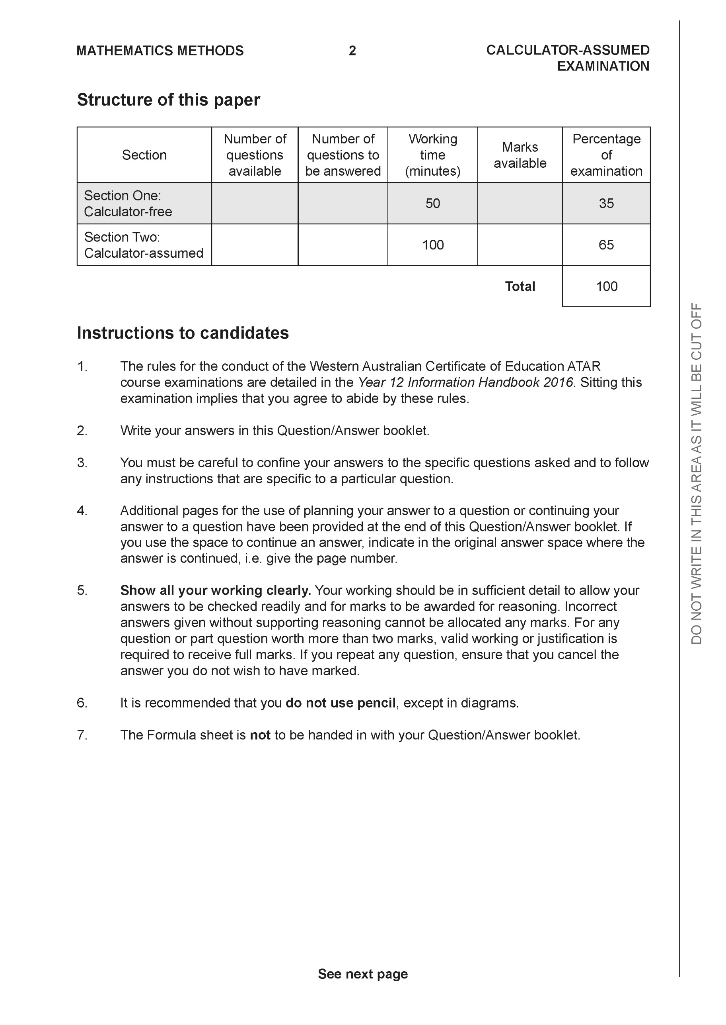

**Section Two: Calculator-assumed (98 Marks)**

This section has **11** questions. Answer **all** questions. Write your answers in the spaces provided.

Spare pages are included at the end of this booklet. They can be used for planning your responses and/or as additional space if required to continue an answer.

● Planning: If you use the spare pages for planning, indicate this clearly at the top of the page.

● Continuing an answer: If you need to use the space to continue an answer, indicate in the original answer space where the answer is continued, i.e. give the page number. Fill in the number of the question that you are continuing to answer at the top of the page.

Working time: 100 minutes.

**Question 8 (5 marks)**

Consider the following system of linear equations with  are constants.



Determine all the values of such that:

1. There will be an unique solution
2. There will be infinite solutions
3. There will be no solutions

|  |
| --- |
| **Solution** |
|  |
| **Specific behaviours** |
| 🗸 eliminates one variable from two equations  🗸 eliminates two variables from one equation  🗸states values for unique  🗸states values for infinite  🗸states values for no solution |

**Question 9 (8 marks)**

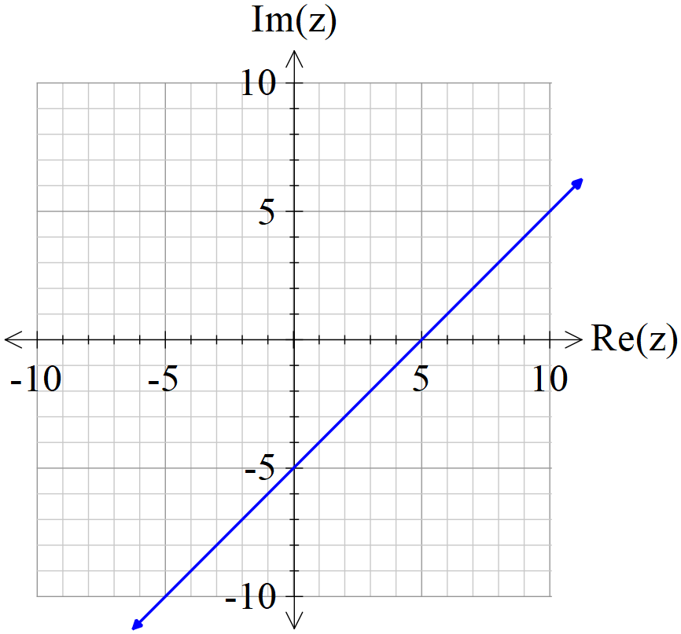

Consider the locus of  which is drawn above.

1. If the locus above can be defined by , determine the constants

. (2 marks)

|  |
| --- |
| **Solution** |
|  |
| **Specific behaviours** |
| 🗸 states a  🗸 states b |

1. Determine the exact minimum value of  on the locus above. (3 marks)

|  |
| --- |
| **Solution** |
|  |
| **Specific behaviours** |
| 🗸 uses perpendicular through origin  🗸 sets up equation  🗸 solves for exact minimum |

1. Sketch the new locus of on the axes above showing major features.

(3 marks)

|  |
| --- |
| **Solution** |
|  |
| **Specific behaviours** |
| 🗸 uses midpoint of 5 & -5i  🗸 draws line  🗸 line is perpendicular (angle labelled) |

**Question 10 (10 marks)**

Let .

(a) Express the complex number  in polar form using the principal argument in radians.

(2 marks)

|  |
| --- |
| **Solution** |
|  |
| **Specific behaviours** |
| 🗸 determines modulus  🗸 determines principal argument |

The complex number  is drawn in the complex plane as shown below.

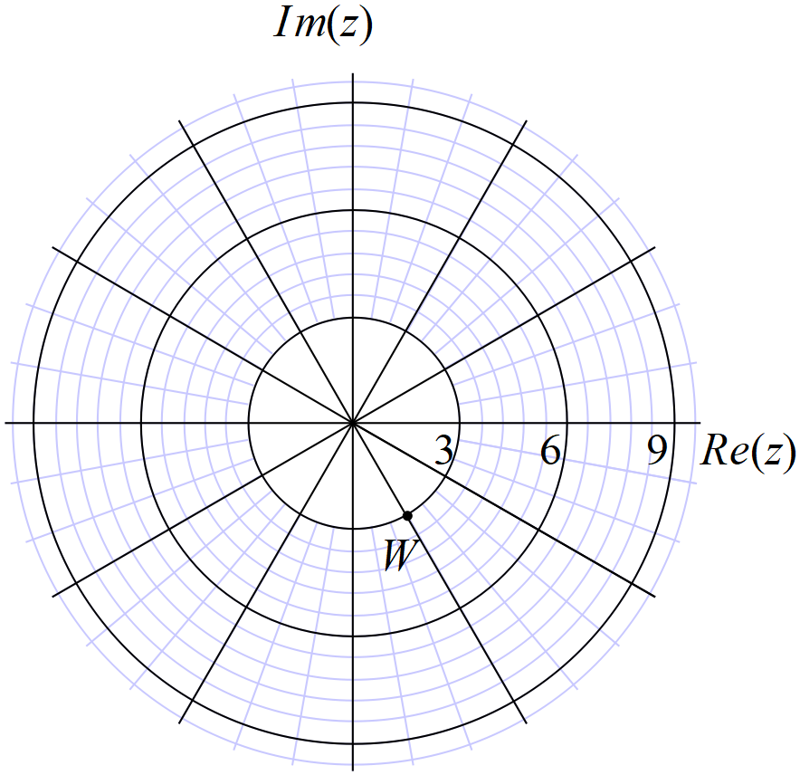

(b) Express the complex number  in polar form using the principal argument (2 marks)

|  |
| --- |
| **Solution** |
|  |
| **Specific behaviours** |
| 🗸 determines modulus  🗸 determines principal argument |

(c) Plot on the axes above, the complex numbers . (4 marks)

|  |
| --- |
| **Solution** |
|  |
| **Specific behaviours** |
| 🗸 zw plotted  🗸  plotted  🗸  plotted  🗸 argument changes by same amount |

(d) Explain geometrically the transformation effect of multiplying by . (2 marks)

|  |
| --- |
| **Solution** |
| Angle decreases by 60 degrees or  Modulus increase by factor of three |
| **Specific behaviours** |
| 🗸 describes effect on argument  🗸 describes effect on modulus |

**Question 11 (9 marks)**

Consider the plane .

(a) Determine the vector equation of a line that passes through Point A and is perpendicular to the plane above. (2 marks)

|  |
| --- |
| **Solution** |
|  |
| **Specific behaviours** |
| 🗸 uses normal vector  🗸 states vector equation |

(b) Hence or otherwise, determine the distance of point A from the plane above. (3 marks)

|  |
| --- |
| **Solution** |
|  |
| **Specific behaviours** |
| 🗸 subs r from line into plane  🗸 solves for parameter  🗸 solves for distance |

**Alternative solution**

|  |
| --- |
| **Solution** |
| Choose any point on plane (0,0,7/2) |
| **Specific behaviours** |
| 🗸 determines any point on plane  🗸 dots vector between tow points with unit normal  🗸 determines approx. distance(no need to round) |

(c) Consider the sphere  where  is a real constant. Determine the value(s) of  so that the line  is a tangent to the sphere. (4 marks)

|  |
| --- |
| **Solution** |
| Alpha = 4.04 only |
| **Specific behaviours** |
| 🗸 subs line into plane equation  🗸 sets up an equation for alpha using magnitude of vector  🗸 equated discriminant of quadratic to zero  🗸 states one positive value for alpha to two decimal places (needs to discard negative value) |

**Question 12 (12 marks)**

Consider the plane  shown below with the following points .

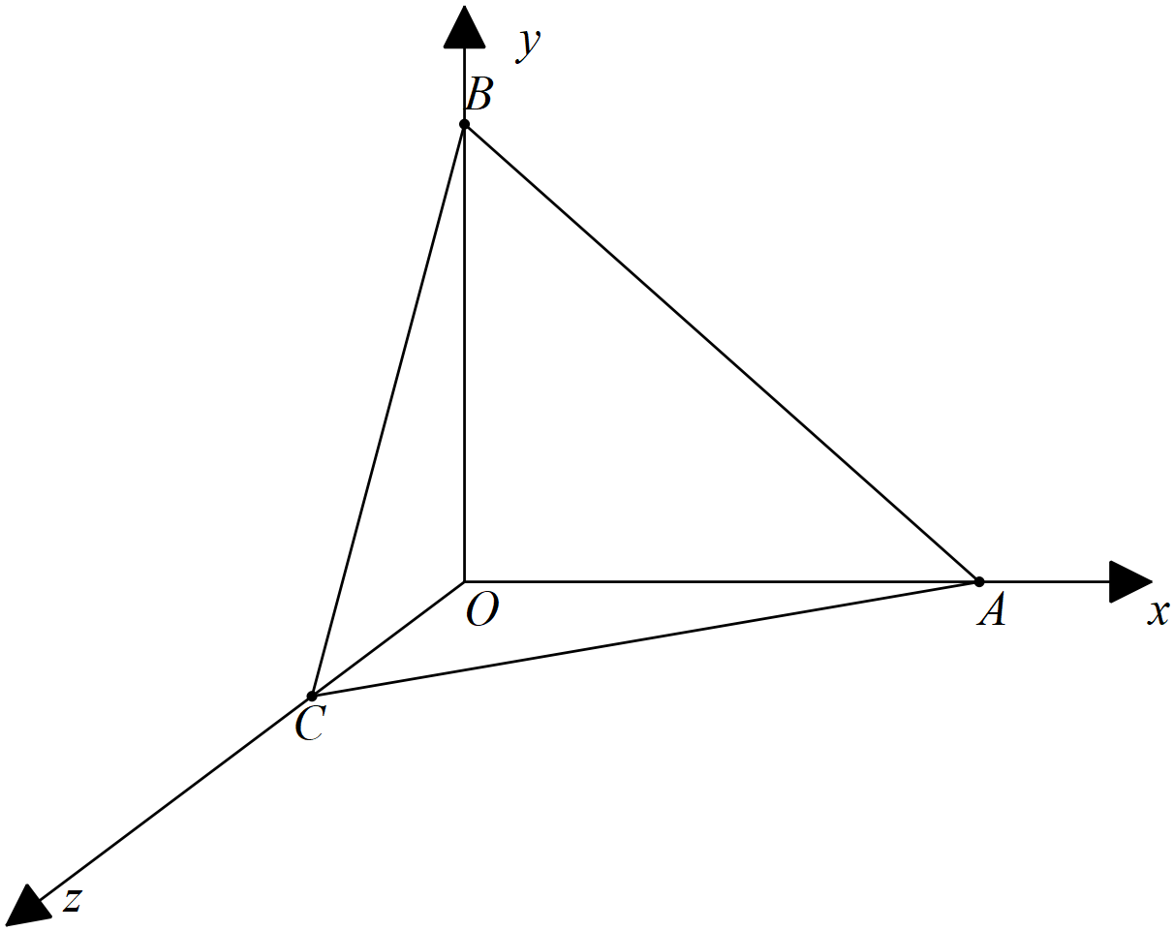

Let  be the midpoints of  respectively.

(a) Determine the position vectors  (2 marks)

|  |
| --- |
| **Solution** |
|  |
| **Specific behaviours** |
| 🗸 States OM vector  🗸 States ON vector |

(b) Using vector methods, show that  trisect each other, that is divide each other in the ratio . (4 marks)

|  |
| --- |
| **Solution** |
| Let P divide BM in ratio 2:1  Let Q divide CN in ratio 2:1 |
| **Specific behaviours** |
| 🗸 defines two points on both line segments with ratio  🗸 shows how to define position vector of one point  🗸 shows how to define other independently  🗸 shows that both vectors are equal hence same point |

(c) Determine using vector methods, the area of the face  (3 marks)

|  |
| --- |
| **Solution** |
|  |
| **Specific behaviours** |
| 🗸 uses vectors in method  🗸 states a correct expression for area  🗸 states area |

(d) Determine the cartesian equation of the plane . (3 marks)

|  |
| --- |
| **Solution** |
| is a normal |
| **Specific behaviours** |
| 🗸 determines normal vector  🗸 derives vector equation  🗸 converts to cartesian |

**Question 13 (5 marks)**

Consider the plane  , which is parallel to a second plane . Given that point  is a point on plane , determine the distance of point  from the plane  to two decimal places.

|  |
| --- |
| **Solution** |
| Choose any point on first plane (0,0,3)    Distance = 10.54 units |
| **Specific behaviours** |
| 🗸 chooses any point on first plane  🗸 Vector subtracts points on either plane  🗸 dots with normal  🗸 using unit normal  🗸determines distance to two decimal places |

**Question 14 (9 marks)**

Particle A started to move with constant velocity  at 11:30am, at 1pm the particle was at position .

(a) Determine the position of particle A at 11:30am. (2 marks)

|  |
| --- |
| **Solution** |
|  |
| **Specific behaviours** |
| 🗸 uses subtraction with t=1.5  🗸 states position vector |

Particle B left  at 1pm, moving with constant velocity .

(b) Determine the distance between the two particles at 2pm that day. (3 marks)

|  |
| --- |
| **Solution** |
|  |
| **Specific behaviours** |
| 🗸 determines positions of both particles  🗸 uses vector difference of points  🗸 determines approx. distance (no need for units) |

(c) Determine the closest distance between the two particles if they maintain their constant velocities and the time it occurs. (two decimal places) (4 marks)

|  |
| --- |
| **Solution** |
|  |
| **Specific behaviours** |
| 🗸 determines expression for displacement vector d  🗸 uses relative velocity  🗸 uses dot product and solves for t from 1pm  🗸 determines approx. distance, no need to round, no units |

Alternative solution

|  |
| --- |
| **Solution** |
|  |
| **Specific behaviours** |
| 🗸 obtains expression for difference in position vectors  🗸 subtracts and determines magnitude  🗸 minimizes expression via calculus/graph/CAS  🗸 states approx. distance, no need to round nor units |

**Question 15 (8 marks)**

A particle moves with acceleration  at time  seconds.

Initially the particle is at the origin with velocity 

(a) Determine the velocity function at time  seconds. (2 marks)

|  |
| --- |
| **Solution** |
|  |
| **Specific behaviours** |
| 🗸 integrates  🗸 solves for vector constant |

(b) Determine the first two times that the particle is moving parallel to the x axis. (3 marks)

(2 decimal places)

|  |
| --- |
| **Solution** |
| Times 0 seconds and 1.43 seconds |
| **Specific behaviours** |
| 🗸 equates y component of velocity to zero  🗸 solves for non negative t values  🗸 at least one time value rounded to two decimal places |

(c) Determine the exact distance of the particle from the origin at time  seconds.

(3 marks)

|  |
| --- |
| **Solution** |
|  |
| **Specific behaviours** |
| 🗸 integrates to find position vector  🗸 solves for vector constant  🗸 determines exact magnitude of r at required time |

**Question 16 (10 marks)**

Consider the following motion defined by  at time  seconds.

(a) Describe the motion. (2 marks)

|  |
| --- |
| **Solution** |
| Circular motion with radius 3 m, angular speed 2 rad/sec |
| **Specific behaviours** |
| 🗸 gives at least one correct description  🗸 gives at least two |

(b) Determine the initial velocity and acceleration. (3 marks)

|  |
| --- |
| **Solution** |
|  |
| **Specific behaviours** |
| 🗸 uses calculus to find velocity and acceleration  🗸 states initial velocity  🗸 states initial acceleration |

(c) Determine the time(s) that the velocity is perpendicular to the acceleration. Justify.

(3 marks)

|  |
| --- |
| **Solution** |
|  |
| **Specific behaviours** |
| 🗸 uses dot product with velocity and acceleration  🗸 obtains un-simplified expression  🗸 shows that simplifies to zero for all values of t |

(d) Determine the exact distance travelled in the first 10 seconds. (2 marks)

|  |
| --- |
| **Solution** |
|  |
| **Specific behaviours** |
| 🗸 shows that speed is 6 m/s  🗸 states distance with units |

**Question 17 (12 marks)**

At midday two rockets, A & B were observed moving in the sky above moving with constant velocities. Their positions and velocities were recorded as below at midday. They appear to have been moving for a number of hours and will continue to do so for many more.



Let  = number of hours from midday.

(a) Determine for Rocket A, the position vector from the origin at time hours. (2 marks)

|  |
| --- |
| **Solution** |
|  |
| **Specific behaviours** |
| 🗸 uses velocity and t  🗸 states position vector |

(b) Determine the cartesian equation for the path of Rocket A. (2 marks)

|  |
| --- |
| **Solution** |
|  |
| **Specific behaviours** |
| 🗸 states parametric equations  🗸 states cartesian equation( no need for parameter) |

(c) Show that the rockets will not collide after midday. (2 marks)

|  |
| --- |
| **Solution** |
| -4*x+4 |
| **Specific behaviours** |
| 🗸 solves for t for one dimension  🗸 solves for another dimension and shows different solution |

(d) Determine the times after midday that the rockets are less than 60 km apart.

(3 marks)

|  |
| --- |
| **Solution** |
| Time lass than 4.5 hours after midday |
| **Specific behaviours** |
| 🗸 obtains expression for displacement apart at x hours  🗸 determines distance apart at x hours  🗸 solves for positive values less than 4.50 hours |

(e) Determine the closest approach from midday and the time that this occurs.

(3 marks)

|  |
| --- |
| **Solution** |
| Closest approach at midday, t=0, at 14.765 km |
| **Specific behaviours** |
| 🗸 graphs expression for distance apart at x hours or uses calculus  🗸 only accepts non negative values of x  🗸 states time and distance, no need to round nor units |

**Question 18 (10 marks)**

Consider a tennis ball moving with velocity  that hits a surface with a normal vector of  as shown in the diagram below.

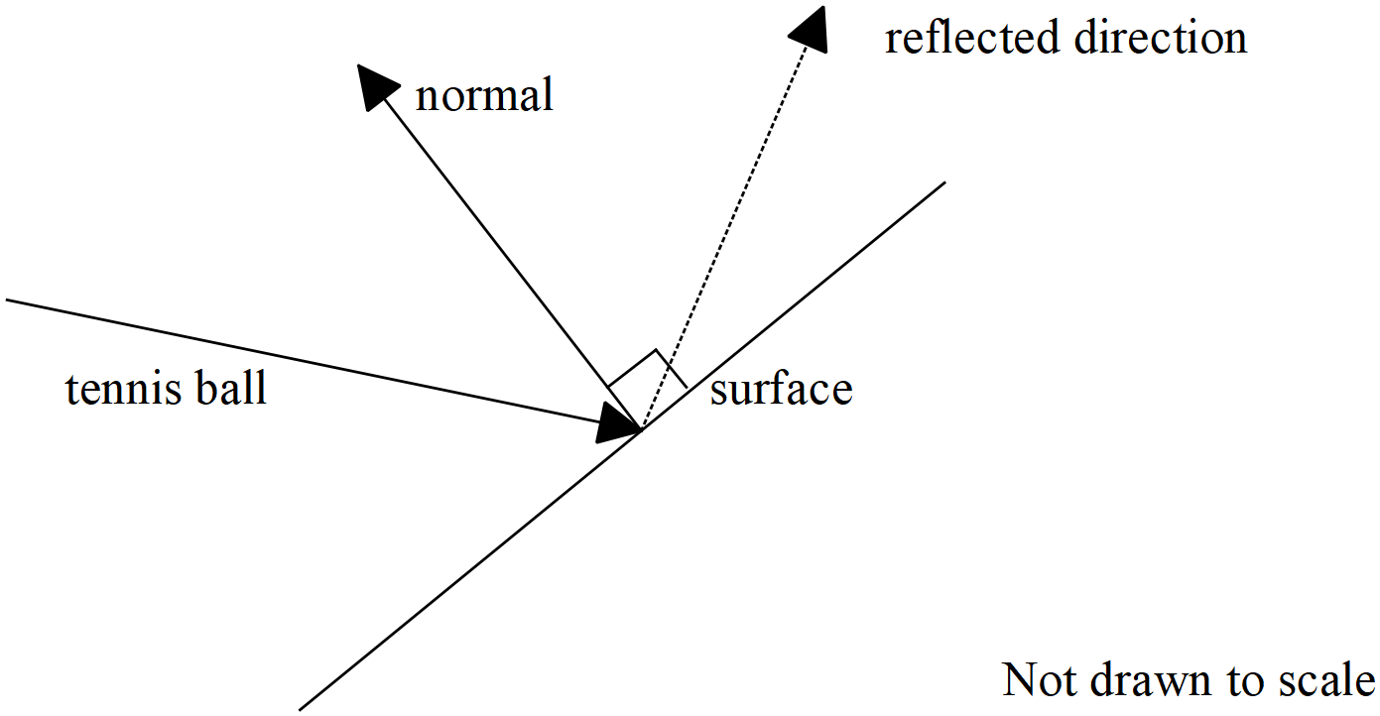

(a) Determine the angle between the velocity vector and the normal vector to two decimal places in degrees. (2 marks)

|  |
| --- |
| **Solution** |
|  |
| **Specific behaviours** |
| 🗸 uses acute or obtuse angle between the two lines in radians or degrees  🗸 states obtuse angle between vectors |

Let the unit vector  be parallel to the reflected direction of the tennis ball. This vector is in the same plane as the velocity and normal vectors above.

(b) Given that the tennis ball is reflected such that the angle with the normal equals that of the incident acute angle with the normal. Show that  when rounded to three decimal places. (3 marks)

|  |
| --- |
| **Solution** |
|  |
| **Specific behaviours** |
| 🗸 uses dot product  🗸 uses acute angle  🗸 shows the derivation of linear equation (no need to round) |

Q18 continue-

(c) Derive another two independent equations for . (3 marks)

|  |
| --- |
| **Solution** |
|  |
| **Specific behaviours** |
| 🗸 uses cross product  🗸 shows derivation of one equation  🗸 shows derivation of both equations |

(e) Solve for to two decimal places. (2 marks)

|  |
| --- |
| **Solution** |
|  |
| **Specific behaviours** |
| 🗸 solves for one unknown  🗸 solves for all three, no need to round |

**Working out space**

**Working out space**